***Database System***

1. **Database** (Collection of related data)
   1. Structured data (In form of relation, table)
   2. Unstructured data
2. **DBMS** (Operations on database)
   1. Sql, mySql, Oracle vers., etc.
3. **RDBMS** (Same as DBMS but in tables(relational) form)

***File System vs DBMS***

1. **Data to be accessed** – In file system, whole data to access for specific but in DBMS, only specified data will be accessed.
2. **Attributes** – Every data has data(meta data) which is not in DBMS.
3. **Concurrency** – DBMS is client server architecture which means clients can access data in the same time with some protocols.
4. **Security**–DBMS has role based access control which means clients with different roles can access different data.
5. **Redundancy** – DBMS doesn’t has redundancy, it has many contraints like primary, foreign keys.

***2-Tier Architecture***



Here, tier means layer.

1. It has 2 layers.
   1. **Client/User**
      1. It’s an iterface.
      2. **Uses API** to fatch data from server/database.
      3. Makes connection w/ server then sends query using DBMS for fatching data.
   2. **Server/Database**
      1. Processes the query then acts upon it and sends data.

**Advantages:**

* **Maintainance** – Easy 2 maintain, as it has only two layer.

**Disadvantages:**

* **Scalability** – When client wants to connect it directly connects w/ database and database will have too much load. So, large no. of clients are difficult in 2-tier architechture.
* **Security** – Here, client directly connects with database without any mediator.

***3-Tier Architecture***



1. It has 3 layers.
   1. **Client/User**
      1. It makes connection with application layer.
      2. Sends query to application layer.
      3. Rest is same as in 2-tier architecture.
   2. **Application layer**
      1. It acts as mediator.
      2. Processes query and acts upon it.
      3. Fetches data from database.
2. **Server/Database**
3. Same as 2-tier database but sends data to application layer.

***Schema***

It’s a **logical representation of DBMS**.

e.g, Making tables to represent data like Student and its marks, roll_no, etc.

***Three Schema Architecture***



By heading, it has 3 schemas,

It’s **theoraticel model**

It is based on the concept of **independence** of levels in databases

1. **External Schema / External Level**
   1. Every view has its own viewer like teacher can access different data while student can access different data or view.
   2. For users.
   3. Interface layer.
2. **Logical Schema / Conceptual Level**
   1. Blueprint of data.
   2. Connecting relational tables.
   3. Database desiging.
   4. No physical data into play.
3. **Physical Schema / Internal Level**
   1. Physical stuffs about data.
      1. Location
      2. Size
      3. File of data
      4. Which hard disk has data

***Data Independence***

Data change in one level doesn’t effect other levels. Take 3-schema architechture as example. There are 2 types of data independence:-

1. **Logical data Independence**
   1. Here, changes in logical/conceptual level doesn’t effect other levels.
2. **Physical data independence**
   1. Here, changes in physical level doesn’t effect other levels.

***Keys***

1. Keys are nothing but attribute or set of attributes used to uniquely identify tuples in the table.
2. Attributes used to uniquely identify tuple in table are candidate keys.
   1. Candidate keys are of two types:
      1. Primary key
      2. Alternate key

**Primary Key:**

* Must be unique attribute and not null.
* Only one primary key allowed.

**Foreign Key**

* Attribute or set of attribute.
* Reference to primary key of same or different table.
* Can be more than one foreign key.
* Maintains *referential integrity* (relation b\w table)
* The table which has primary key is referenced/base table.
* The table which has foreign key is referencing table.



1. INSERT, DELETE, UPDATE
   1. In referenced/base table
      1. **INSERT** – Won’t violate
      2. **DELETE** – May cause violation, as referencing table has its reference

Codes to correct it:

ON DELTETE CASCADE (will delete all referencing value on other table)

ON DELETE SET NULL (sets null in referencing values in other table)

ON DELETE NO ACTION (no action if reference is present)

* + 1. **UPDATE** – May cause violation, as values may present in other table.
  1. In referencing table
     1. **INSERT** – May cause violation, as inserting value which is different in base table.
     2. **DELETE** – Won’t violate.
     3. **UPDATE** – May cause violation, as updating value which is different or not present in base table.

**Super key**

1. It’s a combination of all the possible attributes which identifies two unique tuples in table.
2. Super set of any candidate keys is super key.
   1. For eg, *rollNo(CK) + name = super key*

***Entity-Relationship Model (ER Model)***

1. A representation of relationship between entities.
   1. For eg, *Student* ------study------- *Course*

Here, student and course are objects ie, entity.

**Types of attributes in ER Model**

1. Single valued attribute
   1. Can’t have more than one value.
      1. For eg, Student->*rollNo*
2. Multi valued attribute
   1. Can have more than one value.
      1. For eg, Student->*gmail*
3. Simple attribute
   1. Can’t be further divided
      1. For eg, Student->*rollNo*
4. Composite attribute
   1. Can be further divided
      1. For eg, Student->*subjects->.maths/phy/chem*
5. Stored attribute
   1. Value can’t be derieved from it.
6. Derieved attribute
   1. Value can be derieved
      1. For eg, your age from from you DOB.
   2. **Will have dotted circle in ER Model**
7. Key attribute
   1. Uniquely identify any tuple.
   2. **Will have underline in ER Model**
8. Non-key attribute
   1. Being unique in unnecessary
9. Required attribute
   1. Must be filled
      1. For eg, Student->*name*
10. Optional attribute
    1. Can be skipped
11. Complex attribute
    1. (composite + multivalued) attributes

***Types/Degree of relationship(Cardinality)***

* It represents the number of entity types that associate in a relationship.
* For example, we have two entities, one is a student and the other is a bag and they are connected with the primary key and foreign key.

1. **One-to-one**



* 
  + A third table is formed by their relationship
  + Taking PK of both the tables and refrensing each other with foreign key
  + We can make either of them PK, in third table
  + **\*Third table called as referancing or relationship table\***
  + **Table is reduced towards many side**
    - **Reduced means merging here. ,ll=oll l**
  + Reduce:
    - We can reduce the tables by PK of third table
    - So, 1st table will have extra row which is DID

1. **One-to-many**



* No. of table can be reduced with relationship table.
  + But only reduced to the many side
* 

1. **Many-to-one**
   1. Same as one-to-many
2. **Many-to-many**



* No. of table can’t be reduced.
* 

**Normalization**

* It’s **a technique to remove or reduce the duplicacy or redundancy from the table**.
* While execution, that normalization removes:
  + **Insertion anomaly**(abnormal, a problem)
    - Problem while inserting data
  + **Deletion anomaly**
    - Problem while deleting data
  + **Updation anomaly**
    - Problem while updating data
  + 
* It has two Types:
  + Row level
  + Column level
* **First Normal Form (1NF)**
  + No multivalue in an attribute
  + 
    - Separate table if there is multiple value
    - RollNo from T2 is referencing from RollNo in T1
    - And, it has different values in T3
* **Second Normal Form (2NF)**
  + All non-prime attributes must be full dependent on candidate key.
  + If a non-prime attribute is determined by the candidate part is partial dependency.
  + There should not be **partial dependency(PD)**.
    - Partial dependency means when a non-prime attribute is functionally dependent on part of CK
  + 
    - Here non-prime attribute ‘subjects’ depends on ‘id’
  + 
    - LHS should be proper subset of CK and RHS should be a non-prime attribute
* **Third Normal Form (3NF)**
  + Table or relation must be in 2NF.
  + There should not be partial dependency.
  + There should not be transitive dependency.
  + 
  + 
    - Non-prime attribute should not be determined by non-prime attribute
    - LHS should be CK/SK or RHS should be prime attribute
* Boyce Codd Normal Form (BCNF)
  + Some consider it as special case of 3NF
  + Conditions:
    - Should be a 3NF
    - LHS should be CK/SK
  + 
    - In above fig,
      * CK is rollno, voterid
      * In FD, LHS is CK, hence it’s BCNF
  + 
    - If a table in 2NF it doesn’t mean its 3NF but its possible in vice-versa
    - Above fig. suggests that,
      * BCNF consist of 1,2,3 NF
      * 3NF consist of 1,2 NF
      * 2NF consist of 1NF

**Dependency Preserving Decomposition**

* While decomposition or dividing a table
  + A table must be **lossless**
  + **Dependency** must be **preserved**
  + **All NF ensures losslessness**
  + Dependency is only preserved completely by 3NF
  + BCNF also preserves dependency but its not always the case
  + 
    - In the above example,
      * AB determines CD and D determines A
      * AB is CK but D is not (acc. to BCNF)
        + So we’ve to divide the table
        + From above image, we get AB from AB not ABCD
        + Hence, dependency is not preserved
* **A Gate example**:
  + 
    - Given a table R with FDs and it is decomposed into 3 tables, R1, R2, R3
    - We fetched all the attributes with given attributes
      * And took the common attributes from all tables using FD
      * And, with common attributes if we satisfying FD hence it is preserved.

**Lossless and Lossy decomposition**

* 
  + According to question:
    - We need to find value of C if value of A=1
    - So we’ll divide table in 2
      * i.e, R1(AB) and R2(BC)
    - Query:
      * Select R2.C from R2 Natural Join R1 Where R1.A=’1’
    - We have to do Cross product of both the table by taking value of R1 with all values of R2
    - From above image,
      * Remove rows having different B values in R1 and R2
      * And, join the table with same B into B
    - Joined table will look like this, (in below image)
* 
  + Joined table has 2 more tuples than original table
    - This extra tuples are called, **Spurious tuples**
  + This extra tuples are lossy decomposition
    - **Lossy in terms of consistancy**
* In order, to remove losslessness we’ve to divide table based on:
  + **We’ve to table common a CK or SK from first table or second table or both**
  + Which is R1(AB) R2(AC) where common is A
* 
  + In union, we should get all attributes
  + In intersection, it shouldn’t be null
  + CK can be from R1, R2 or both.

**Summary of NFs**

* 
  + **1NF**
    - No multi-valued attribute
    - Only single value
  + **2NF**
    - No partial dependency
  + **3NF**
    - No transitive dependency
    - No non-prime attribute should determine non-prime attribute
  + **BCNF**
    - LHS must be CK or SK
  + **4NF**
    - No multivalued dependency
  + **5NF**
    - Lossless decomposition

**Closure method**

* It’s a method to find all the candidate keys in a table.
  + Candidate key must be a minimal value like A, B
    - If not, it’ll be a super key like AB, BC
* 
  + A->B, means A can determine B
  + A+ = BCDA, means A can determine BCDA
  + **Candidate key has all the attributes**
    - All attributes in CK are **prime attributes**
  + In second example,
    - R(ABCDE), there is no E in right side so we’ve to add E in left side also
    - So CK is BE+
      * Having prime attribute, B,E,C,D,A

**Functional Depandancy**

* It’s a relationship between attributes of a table dependent on each other.
* 

**Minimal Cover**

* 
  + We’ll be given a FD
  + We just have to find minimal cover(irreducible set of attributes)
  + For example(from above image),
    - In step 1, we wrote all the attributes
    - In step 2, we wrote all the attributes which is not a CK(closure of any attribute that finds all the attributes)
    - In step 3, again we further removed all CK
    - Remaining is the minimal cover

Equivalence of Functional Dependancy

* 
  + Equivalence of FD means checking if both the FDs are equal
    - Here, equals means:
      * Lets suppose there are 2 FDs i.e. X and Y
      * If X covers Y and Y covers X
        + Then we say 2 FDs are equal
  + We check the equivalence by checking Y through X and vice-versa
  + In above image,
    - We checked X through Y by taking attributes from Y and checking if it’s covering same attributes as X using closures, hence Y covers X
    - And, same for X covers Y

**Joins**

* **A JOIN clause is used to combine rows from two or more tables, based on a related column between them.**
* 
  + Suppose a scenario, we have 2 tables employee and department table
    - And, we have to get a empoyee who is from HR department
    - In this, scenario we have to use JOINS
  + **Joins = cross product + select statement(condition)**
  + **Types**
    - Cross join
    - Natural Join
    - Conditional join
    - Equi join
    - Self join
    - Outer join
* **Natural JOIN**
  + **A NATURAL JOIN is a JOIN operation that creates an implicit join clause for you based on the common columns in the two tables being joined**
  + 
    - Given tables, **emp**, and **dept**
    - If we have to select something from any one table only:
      * SELECT e_name FROM emp WHERE address=”Delhi”
    - In Natural JOIN, we join using similar clauses from both the tables
      * For example, if we have to get **e_name** who is in HR dept
      * We do:
        + SELECT e_name FROM emp, dept WHERE emp.e_no = dept.e_no
        + Here, (emp, dept) **is cross-product** which is in the left side of above image
        + (emp.e_no = dept.e_no) **will do the natural join**
        + 

After Natural join, we get emp and dept table having similar **e_no**

* **Self JOIN**
  + **A self join is a regular join, but the table is joined with itself.**
  + 
  + Given 2 tables, **Student** and **course**, then we have joined **study** table having **s_id**, **c_id** and since
    - We have to apply self join here,
      * SELECT T1.s_id FROM study as T1, study as T2 and T1.c_id <> T2.c_id
      * Where,
        + study as T1, study as T2 are **alias of study** or instances of study and we are **doing cross-product** here
        + T1.c_id <> T2.c_id means where **T1.c_id != T2.c_id**
        + SELECT T1.s_id means we selecting from T1 as primary
    - After self join, we get table having ticked mark on left cross-product.
* **Equi JOIN**
  + **An equi-join is a join based on equality or matching column values. This equality is indicated with an equal sign (=) as the comparison operator in the WHERE clause.**
  + 
  + Given 2 tables emp and dept where dept has FK to emp table as e_no
  + We have to find emp name where address of emp and location of dept is matching
    - SELECT e_name FROM emp, dept WHERE emp.e_no = dept.e_no and emp.address = dept.location
    - Where,
      * Emp, dept is doing cross-product which is in left side of image
      * WHERE emp.e_no = dept.e_no and emp.address = dept.location, here first matching e_no and then doing equi join with emp.address = dept.location where its “=” is doing equi join
    - After all the cross-product and condition we get answer “Ram”
* **Outer JOIN**
  + **Left outer join**
    - In this join, we are getting conditional matching value but also we are getting whole left table
    - 
    - Given, emp and dept table where we have to get all tables matching dept_no plus left outer join
      * SELECT emp_no, e_name, d_name, loc FROM emp left outer join dept ON (emp.dept_no = dept.dept_no)
        + Where,

emp_no, e_name, d_name, loc, its values we’ve to find

emp left outer join dept, here left outer join will happen

ON, its condition

* + - * We get the result as table in the bottom left of the image, ***see we get extra E4 which is due to left outer join***
  + **Right outer join**
    - **Same as left outer join but we won’t get extra E4.**
    - If there is extra values in left and right table we’ll get extra value of E4 due to right outer join.
  + **Full outer join**
    - **Same as other join but we get union of both the tables.**
* **Cross JOIN**
  + **This returns all the records**
* **Conditional JOIN**
  + **Returns joined table based on the conditions.**

**Relational Algebra**

* It’s a procedural query language.
* It’s a theoratical framework used to describe and analyze operations in databases.
  + Where operations are mathematical expressions.
  + 
* **Projection (π)**
  + Denoted by phi
  + 
  + It only fetches unique values like roll_no and while fetching name it only shows unique value and removes similar values.
  + Πroll_no(student)
    - It’ll fetch only roll_no
* **Selection (σ)**
  + 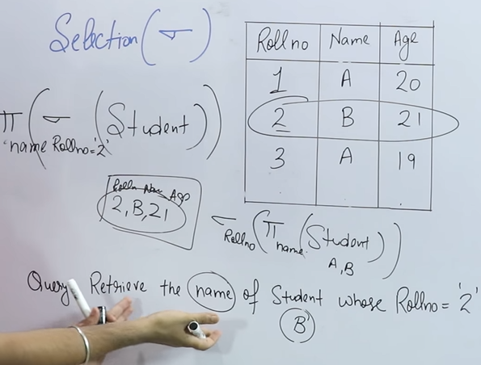
  + It is used to select
  + Projection is a column retrival query
  + Selection is a row retrival query
  + π name(σroll_no(student))
    - it’ll retrive name ‘B’ row
  + σroll_no(π name (student))
    - It’ll retrive only name ‘B’
* **Cross-product (x)**
  + 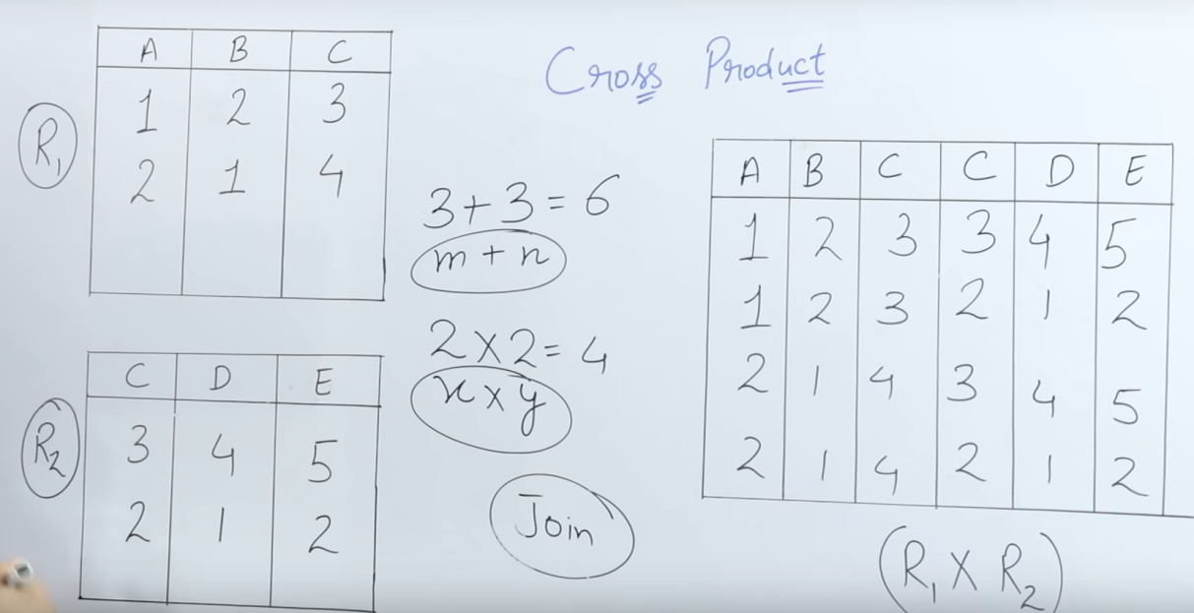
  + Must for joining tables
  + Here, we apply product of each row from a table with every other row of other table.
  + It must have one or more than one column having common elements
  + Row = sum of elements on both the tables
    - i.e. 3 + 3 = 6
  + column = multiplying rows in both the tables
    - i.e. 2*2 = 4
* **Set Difference (-)**
  + 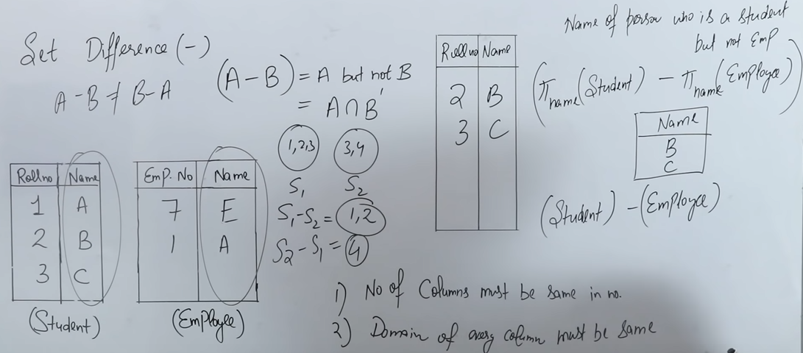
  + It’s an intersection
  + Given table student and employee
    - If we apply
    - πroll_no(student) - πroll_no(employee)
    - we’ll get table having,
      * Name -> B, C
* **Union (u)**
  + 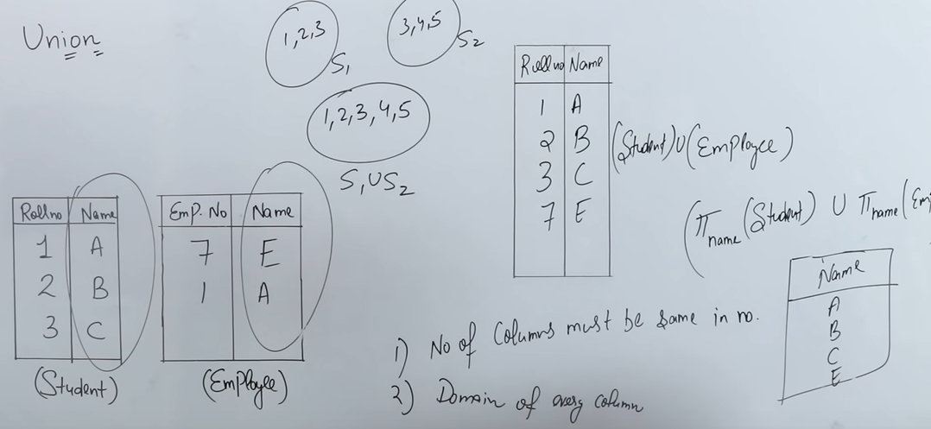
  + It’s an union
* **Division operation/Division methods**
  + 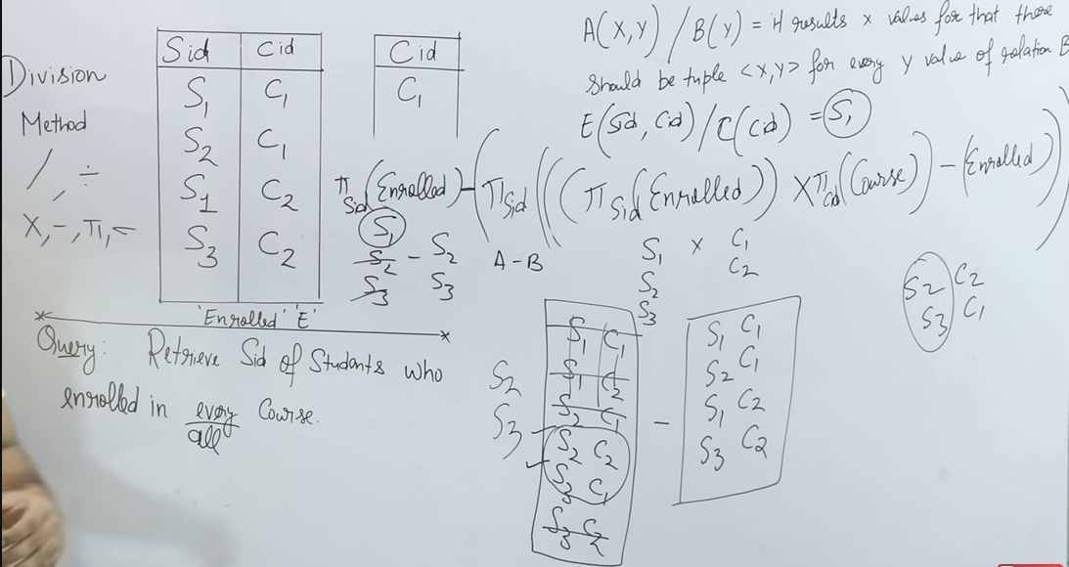
  + A(x, y) / B(y) = It results x values for that there should be tuple <x, y> for every y value of relation B. For example:
    - Given tables, E and C
    - E(Sid, Cid) / C(Cid) = S1
    - We got S1 coz I has both C1 and C2

**SQL (Structured Query Language)**

* Stands for “**Structured Query Language**”
* It’s used by users to interact with database.
* Called as SEQUEL coz once upon a time it was called as “Simple english query language”
* It’s a **domain-specific language**
  + Languages are generally of two types:
    - General-specific language
      * Can be used generally like c, c++
    - Domain-specific language
      * Can be used for certain domains like structure which is relations or tables
* It’s a **declarative language**
  + Languages based on working are of 2 types:
    - Procedural language
      * “What to do” and “how to do”
    - Declarative language
      * “what to do”
* It has **DDL, DML, DCL, TCL** commands
* **Keys** and **constrains**
* Operators (like, not like, in, not in, conditional, exist, not exist)
* Clauses (distinct, order by, group by, from having)
* Aggregate function (average, count)
* Imp points: Joins and Nested Queries
* **PL SQL(Procedural Language – SQL)**
  + Triggers function
  + Cursor procedures

**SQL Commands**

* Data Defination Language (DDL)
  + It is **operations performed on the structure**
  + Commands:
    - **CREATE**
    - **ALTER**
      * Modifying structure
    - **DROP**
      * Removes structure
    - **TRUNCATE**
      * Removing data from structure
    - **RENAME**
* Data Manipulation Language (DML)
  + It is performed after DDL
  + Commands:
    - **SELECT**
    - **INSERT**
    - **UPDATE**
    - **DELETE**
* Data Control Language (DCL)
  + Giving or removing privilages to users
  + Commands:
    - **GRANT**
    - **REVOKE**
* Transaction Control Language (TCL)
  + Controlling transaction of data
  + Commands:
    - **COMMIT**
      * Sending latest changes
    - **ROLLBACK**
    - **SAVEPOINT**
      * Saving changes at any point like video game
* Constraints
  + Primary key
  + Foreign key
  + Check
  + Not null
  + Unique
  + Default

**Commands:**

* **CREATE**
  + 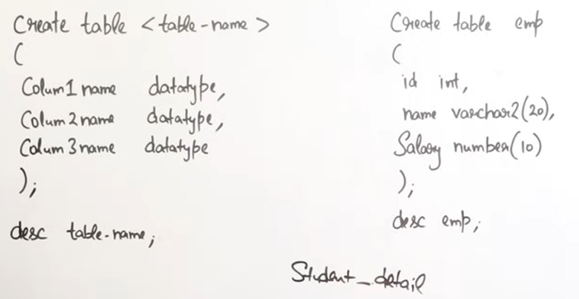
  + Left one is syntax and right one is code
  + No comma ‘,’ before ending parenthesis
* **ALTER**
  + **ADD** column/s
  + **REMOVE** column/s
  + **MODIFY** datatype
  + **MODIFY** datatype length
  + **ADD** constraint
  + **REMOVE** constraint
  + **RENAME** column / table
  + Example:
    - **Alter table student_details ADD address varchar(30)**
    - **Alter table student_details DROP address**
    - **Alter table student_details MODIFY address varchar(10)**
    - **Alter table student_details RENAME column address to roll_no**
    - **Alter table student_details rename to employee**
    - **Alter table student_details ADD primary key (address)**
* **Difference between ALTER and UPDATE**
  + **ALTER** for the structure
  + **UPDATE** for the data in structure
    - UPDATE table set salary = salary*2 where id = 1
* **Difference between DELETE, DROP and TRUNCATE**
  + 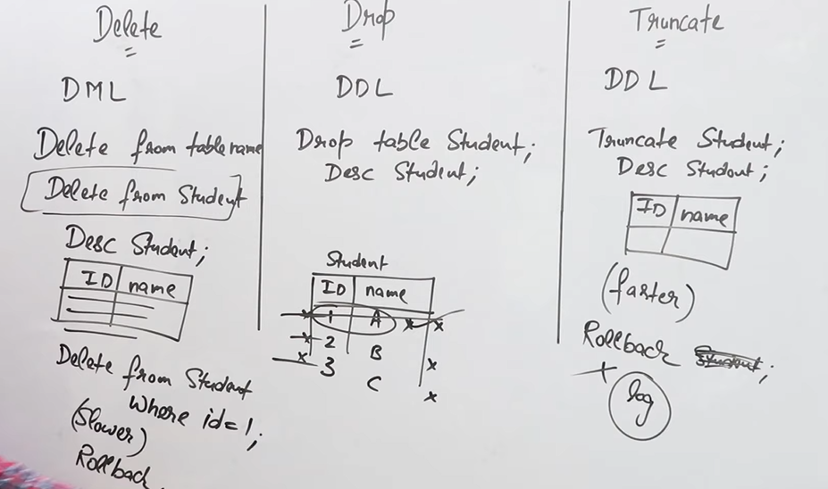
  + DROP deletes whole attributes, column row nothing left
    - DROP table student;
  + DELETE deletes only the row line by line
    - DELETE from student;
    - DELETE from student where id = 1;
  + TRUNCATE deletes all the rows at once
  + **DELETE** is **slower**
  + **DELETE** makes **logs** so it can **rollback** but others can’t

**Constraints on SQL**

* **UNIQUE**
  + Contents in the column must be unique
* **NOT NULL**
  + Data in the column must not be empty
* **PRIMARY KEY**
  + **UNIQUE** + **NOT** **NULL**
  + Only one primary key in the table
* **CHECK**
  + For example, we can check if age is above 18 so users can’t add age below 18
  + Also, we can also add to choose between given values
* **DEFAULT**
  + Default values for the column
* **FOREIGN KEY**
  + Reference to other table

**Queries and Sub-queries**

1. 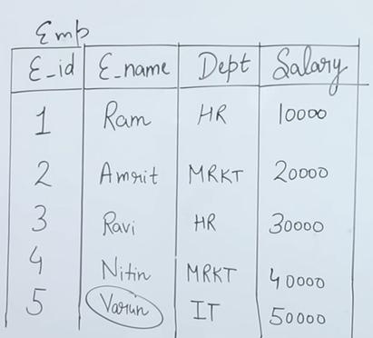
   1. Maximum salary
      1. SELECT Max(salary) from emp; //50000
   2. Name of the employee getting max salary
      1. SELECT e_name from emp where salary = (SELECT Max(salary) from emp; //Varun
      2. It’s a nested query
   3. Second max salary
      1. SELECT Max(salary) from emp where salary <> (SELECT Max(salary) from emp; //Nitin
         1. Where ‘**<>**’ is **not equal to**
   4. Display dept names along with the no. of employees working there
      1. SELECT dept from emp group by dept;
         1. **Group by, aligns item by groups e.g. HR HR MRKT MRKT IT**
         2. We can select only dept if we are grouping dept otherwise we’ve to use aggregate functions.
      2. SELECT dept, count(*) from emp group by dept;
         1. **Count(*) will count all dept**
         2. We can also type count(dept)
         3. 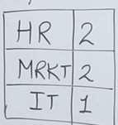
   5. Display dept having no. of employees less than 2
      1. SELECT dept from emp group by dept having count(*) < 2;
      2. If we want to display name
         1. SELECT e_name from emp where dept In (SELECT dept from emp group by dept having count(*) < 2);
         2. **Where ‘In’ can be called equal to or include**
            1. **Mostly it’s used for comparing with more than 1 value**
   6. Display highest salary dept wise and show their names too
      1. SELECT dept, Max(salary) from emp group by dept;
      2. SELECT e_name from emp where salary In (SELECT dept, Max(salary) from emp group by dept);
         1. **Where ‘In’ used instead of ‘=’ because we are getting more than one value**
2. 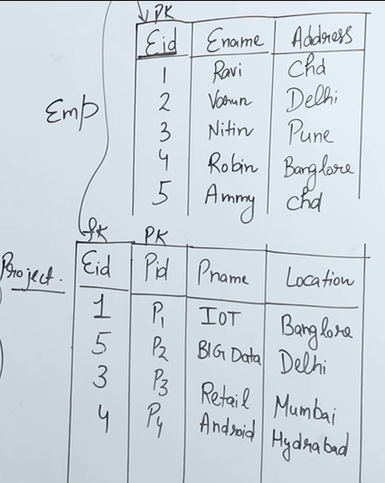
   1. Use of In
      1. SELECT * from emp where address In (Delhi, Pune)
      2. Where, **‘In’ is used to compare with multiple values**
      3. Inner/Outer query
         1. SELECT e_name from emp where eid In (SELECT Distinct(eid) from project);
         2. Where, **Distinct is used to display only unique values**
   2. Use of Not In
      1. SELECT * from emp where address Not In (Delhi, Pune)
      2. Where, **‘Not In’ is used to compare with multiple values but returns value which is not returning true while comparing**

**Queries**

* Exists/ Not Exists

1. SELECT * from emp where eid exists (SELECT eid from project where emp.eid = project.eid)
2. Outer query is connected to inner query i.e. **corelated nested** query, using Exists/ Not Exists
3. **So, in exists one row of outer query is compared to all the rows of inner query to check that rows exists in inner row or not and it returns true/false based on the comparision.**
4. **So, in not exists one row of outer query is compared to all the rows of inner query to check that rows not exists in inner row or not and it returns true/false based on the comparision.**

* **Aggregate Functions**
  + Max()
    - Returns max of the chosen tuple/value
    - SELECT Max(salary) from emp;
  + Min()
    - Returns min of the chosen tuple/value
    - SELECT Min(salary) from emp;
  + Count()
    - Returns no. of rows in the chosen column
    - SELECT count(*) from emp; //returns no. of rows in emp
    - SELECT count(salary) from emp;
      * If salary has 6 rows where 6th is null then it’ll return 5
  + Sum()
    - Returns sum of chosen column
    - SELECT Sum(salary) from emp;
  + Avg()
    - Returns average of chosen column
    - SELECT Avg(salary) from emp;
      * Avg(salary) = Sum(salary) / Count(salary)
  + Distinct()
    - It is used to take only unique values
    - SELECT distinct(sum(salary)) from emp;
    - SELECT distinct(count(salary)) from emp;
* Correlated Subquery (Synchronized Query)
  + It’s a **subquery that uses the value of outer query**.
  + It’s a **top-down approach** i.e. first outer query happens then inner query
  + For example:
    - SELECT * from emp where eid exists (SELECT * from dept where emp.eid = project.eid);
* Nested subquery
  + It’s a **subquery that first fetches inner query then outer.**
  + It’s a **bottom-up approach** i.e first inner query happens then inner query
  + For example:
    - SELECT * from emp where e_id In (SELECT e_id from dept); //returns all row having same e_id

**Question: Find Nth highest salary**

* **Highest**: SELECT Max(salary) from emp;
* **Second Highest**: SELECT Max(salary) from emp where salary Not In (SELECT Max(salary) from emp);
* **Nth highest**: SELECT id, salary from emp e1 where N-1 = (SELECT Count(Distinct salary) from emp e2 where e2.salary > e1.salary);
  + Where N is the Nth highest number
  + 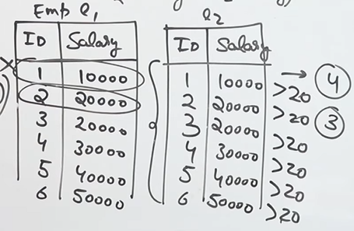

**Question:**

* 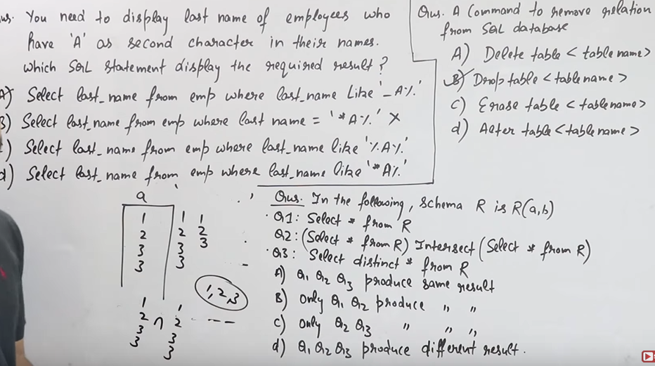
  + Question 1:
    - To select specific character of a word we have to use Like
    - **Like %A%,** it means there is A in between the words but there can be any number of characters in left as well as right side
    - **Like _A%,** it means there is only one character on left and many characters in the right
    - **Like %A_,** it means many characters on left but only one in right
    - *Answer is A*
  + Question 2:
    - Remove relation(Table)
    - It’ll require DDL
    - *Answer B*
  + Question 3:
    - Q1: All result from relation R
    - Q2: **distinct common(due to intersect)** result from R
    - Q3: distinct common result from R
    - Answer is C

**PL-SQL (Procedural SQL)**

* 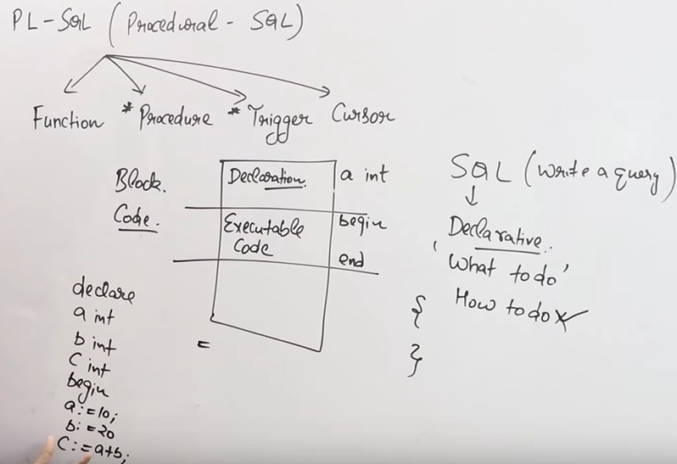
  + It has 4 parts:
    - **Function**
    - **Procedure**
    - **Trigger**
    - **Cursor**
  + It is **procedural language** i.e. it is “What to do” and “How to do”
  + Codes are like the code written on bottom left
    - **“:=”** to assign value
    - **“=”** to compare
  + In sql questions, we get write a sql but in pl-sql we get write a pl-sql block/code
  + Code can have declaration, executable code and error handling

**Transaction Concurrency**

* Transaction: It is a **set of operations used to perform logical unit of work**.
  + It **represents change in database**.
  + Same as transaction in bank but instead of money we use data in database
* 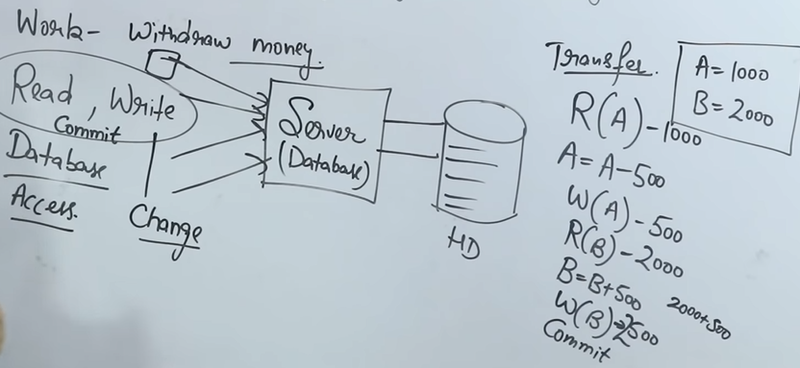
  + **We can only perform read/write operation but there are other operations like commit and rollback too**
  + We **first interact with database then data**
  + In right side, Transfer
    - We are performing, transferring 500 from A to B
    - R is for read and taking data
    - W is for changing data
    - It is **performed on CPU through data in cache/ram due to speed efficiency**
* **ACID Properties**
  + It stands for Atomicity, Consistency, Isolation, Durability.
  + Atomicity:
    - **Either all or none.**
    - It means either all the operations is done till commit or nothing happened.
    - For example:
      * In above example of giving 500, so in atomicity either 500 is given to B or not.
  + Consistency:
    - **It means maintaining integrity of the database or correctness of database.**
    - In other words, **data before changing and after changing is same**.
    - For example:
      * Let suppose A has 4000 and B has 1000, A is giving B 1000 so now, A has 3000 and B has 2000. In this case, there was 5000 before transaction and 5000 was there even after transaction
  + Isolation:
    - **Multiple transaction can occur concurrently without leading to inconsistency of database state and without interfering in transaction with each other.**
  + Durability:
    - **After the transaction, data is updated, modified and then stored on to persist even after system failure**.
    - Here, updates are permenently stored on non-volatile memory.
* **Transaction States**
* States of transaction are:
  + 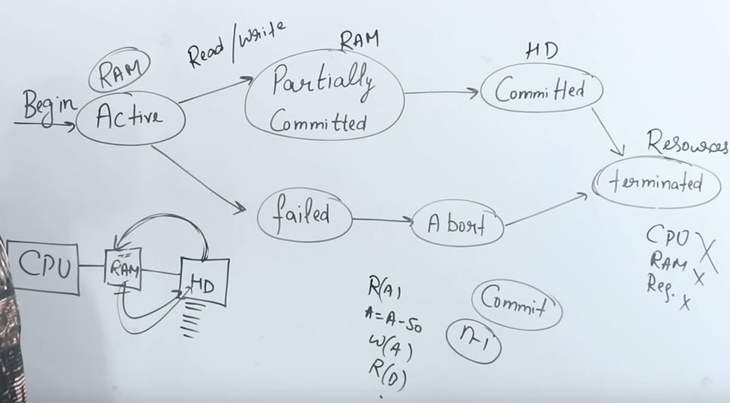
  + Begins, we take the data from HD(hard disk) for performing operations.
  + Active:
    - For performing **we take data from HD to RAM for faster performance due to CPU’s ALU operations**.
    - Basically, **read/write is performed on data and reading means taking data from HD to RAM**.
  + Partially Committed
    - **Performing operations but not committing**.
  + Committed
    - It means **saving all the operations in HD from RAM**.
  + Terminated
    - **De-allocation of resources from RAM**
  + Failed
    - Due to some reason if transaction is failed it comes in this state
    - Basically **failure in transaction from Active and Partially Committed**
  + Abort
    - **After Failed state, operation is Killed/Restart**.
* **Schedule**
  + It’s a **chronological execution of sequence of multiple transaction**.
  + It is of two types:
    - Serial Schedule
      * Suppose there are 3 transaction T1, T2, T3
      * Here, **operations will be performed one by one** i.e. serially.
      * First T1, then T2, T3
      * **Advantage**:
        + **Consistency**.
      * **Disadvantage**:
        + **Performance is decreased**
        + **Throughput is low** i.e. transaction performed per unit time
    - Parallel Schedule
      * Here, transactions are performed parallely.
      * We can **perform stop or continue any operations** here.
      * **Advantage**:
        + **Performance is high**
        + **Throughput is high**
      * **Disadvantage**:
        + **Consistency**
* **All Concurrency Problems**
  + Dirty Read
    - 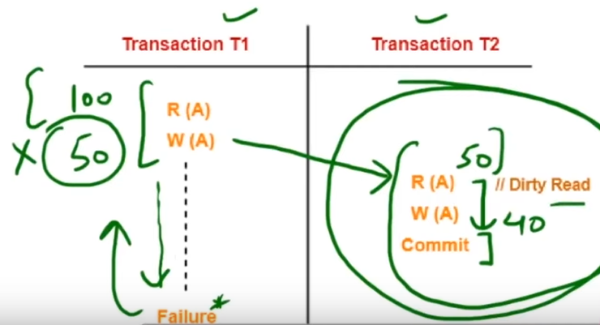
      * In parallel scheduling having T1, T2
      * Suppose in T1, it read A(100) then write it to 50 and T2 read the value.
      * After some operations T1 failed due to any reason so the value taken by T2 is dirty i.e. Dirty read
  + Incorrect Summary
    - 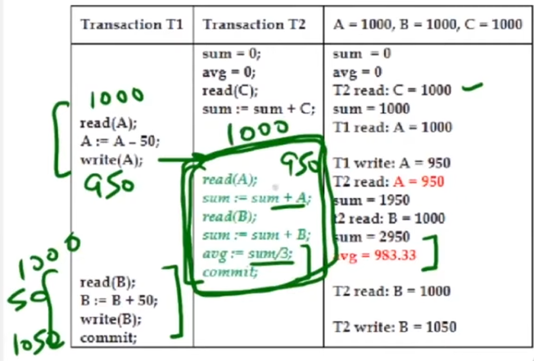
      * In this, when other transaction does some aggregation in between the transaction that results in the wrong value.
  + Lost Update
    - 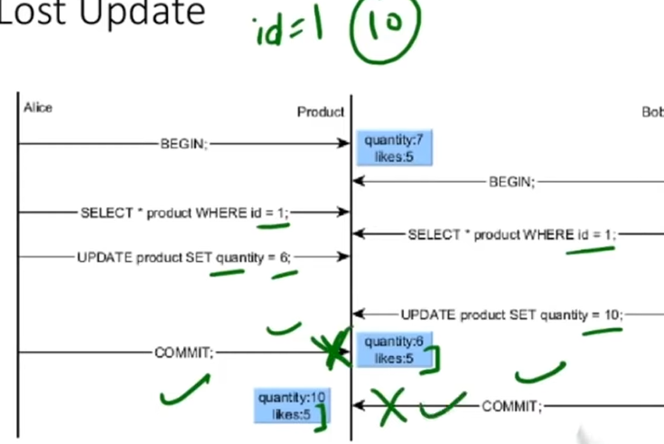
      * Change in value due to updation through other transaction
  + Unrepeatable read / read-write conflict
    - 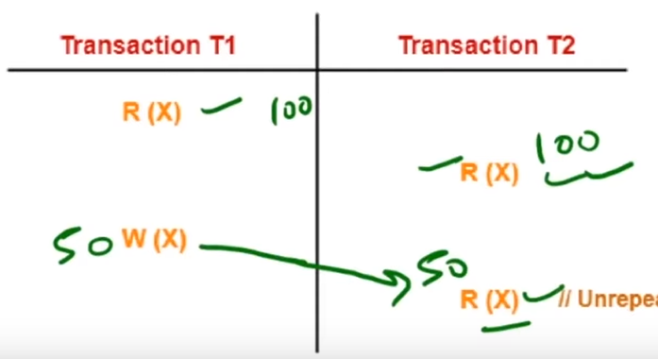
      * Suppose, T1 read the value(100) then T2 read the value(100) and then T1 write the value(50) and commited then again T2 read the value(50).
      * The person doing T2 didn’t done anything other than reading still value changed from 100 to 50
      * This is read-write conflict
  + Phantom read
    - 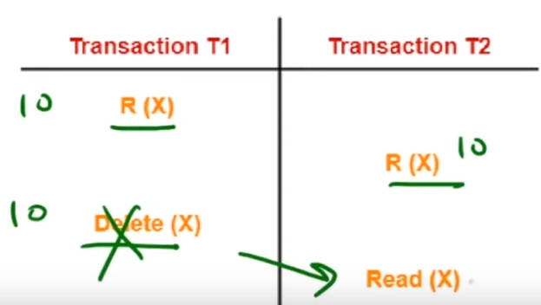
      * Same as unrepeated read but it’ll try to read deleted value.

**Recoverable vs Irrecoverable Schedule**

* Like Dirty read problem, where T1 rollback to initial state after transaction failing but T2 still has the read value, in this case it is irrecoverable.

**Cascading Schedule vs Cascadeless Schedule**

* Cascading Schedule
  + **Cascading means due to one operation multiple operations are occuring**
  + 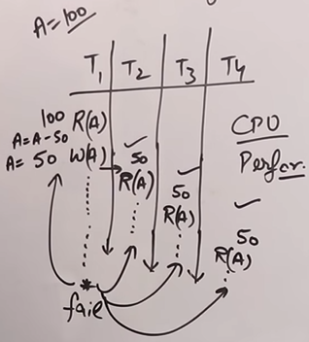
    - Like dirty problem, but T2 read from T1, T3 read from T2 and T4 read from T3
    - If T1 failed and rollback, then T2, T3, T4 will rollback too.
    - This causes CPU performance waste problem.
* Cascadeless Schedule
  + In this**, if T1 is not successfully commited T2 can’t read it.**
    - It solved the Cascading Schedule problem
  + Write-write problem
    - 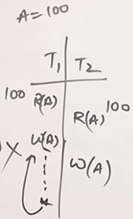
      * It stops us from reading the file after write operation but what about writing?
      * So we can still write after write operation in T1 and if T1 fails in future, then there is problem in T2.

**Serializability**

* 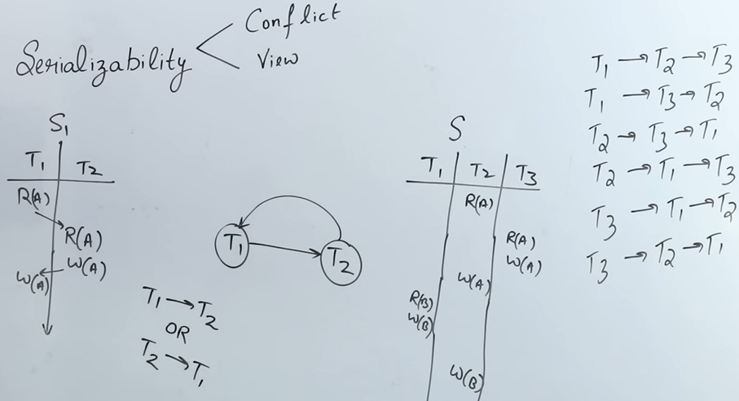
* **Serializability is the process of converting parallel schedule in serial schedule.**
* We convert by taking all the possible flow of process from all the transactions.
* **It can be done using 2 process:**
  + Conflict Equivalent Serializability
    - 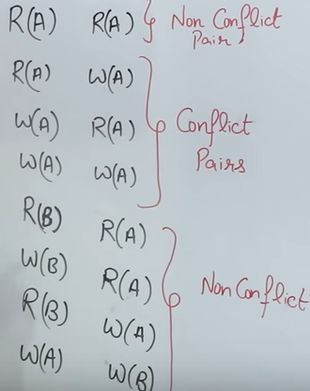
      * In above image, we can see pairs upper and lower one is non-conflict pair while middle one is conflict pair.
    - 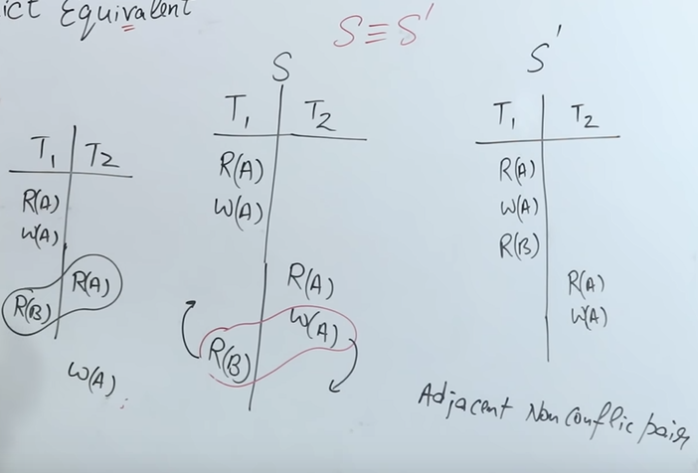
      * We’ve given S and we have to convert to S’
      * We **convert by taking adjacent non-conflict pair and moving them in opposite rows tilll we get S’**
    - 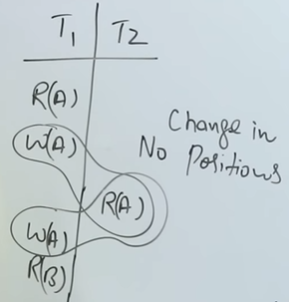
      * **If we’ve adjacent conflict pair then no swapping no change in positions.**
    - 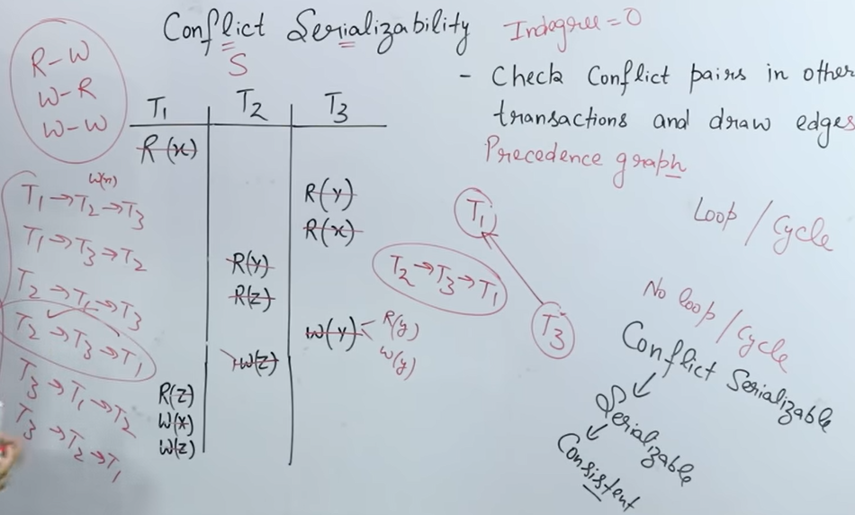
      * **Questions:** We’ve given a table/transactions T1, T2, T3.
      * Here, we’ll **check conflict serializablity, serializable, consitent**
      * **We’ll check by finding conflict pair of selected element with other columns/transactions and in below rows.**
      * We’ll **make a graph after finding conflict pairs**.
      * 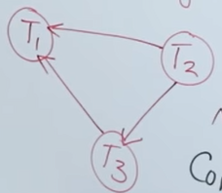
        + It has **no loops/cycle, i.e. it is serializable**
        + We’ll **remove the indegree transaction** i.e. transaction where no arrow comes.
        + We’ll get by removing Transactions,

**T2 -> T3 -> T1**

* + - * + It **should match one of the possibilities of the flow of transactions**.
        + If it’s **serializable it is consistent**.
  + View Serializability
    - **Why we need view serializability?**
      * 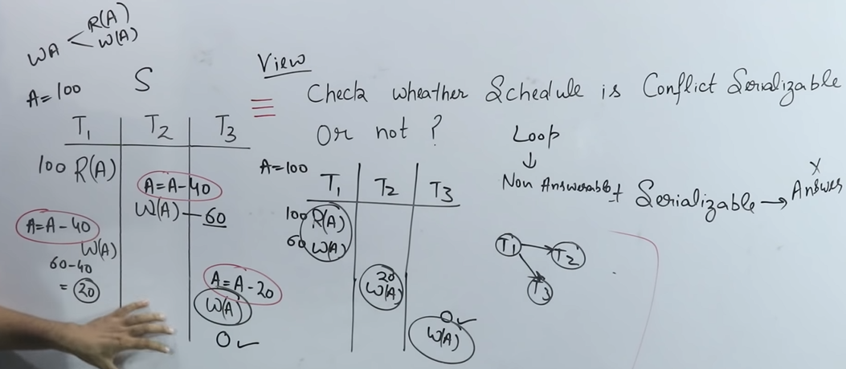
      * After we check conflict serializability**, if there is loop in graph we can’t say if it is serializable or not.**
      * So, we’ll use view serializability,
        + In left most table, we can see from 100 we get to 0 after operations.
        + In right table, we also get 0 and a graph having no loop
        + So we can say it’s serializable

**Shared-Exclusive Locking**

* It **comes under transaction concurrency control(TCC)**
* **Schedules are already concurrent, so it makes sure the schedule should be serializability and recoverable**.
* It has **two locks:**
  + **Shared Lock(S)**
    - In this, transactions are allowed for **read only**
  + **Exclusive Lock(X)**
    - In this, transactions are allowed for **read/write both**.
* 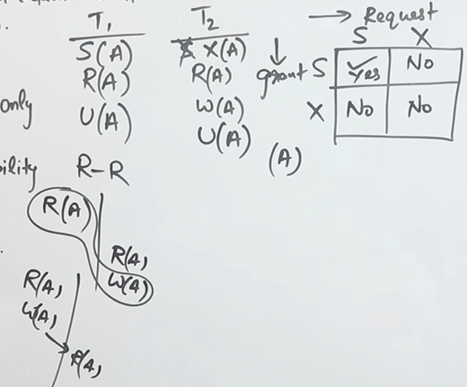
  + **Upper left T1, T2 is the exaple of shared/exclusive lock**
  + **S(shared), X(exclusive), U(unlock)**
* So basically for **requesting shares lock, concurrency control component checks compatibility table** which is in right side of above image
  + It is SS, SX, XS, XX
    - SS (yes), can be read multiple times
    - SX (no), after read writing can cause inconsistency in value
    - XS (no), after write if we read it’ll cause inconsistency
    - XX (no), writing multiple times can cause inconsistency as well
* Problems:
  + May not be sufficient to produce only serializable schedule
  + May not be free from irrecoverability
  + May not be free from deal-lock
    - Sometimes it can’t get grant due to other transaction got the grant
  + May not be free from starvation
    - It means waiting for grant for so long period of time

**2P Locking (2PL)**

* **Growing phase**
  + **Locks are acquired and no locks are released**
* **Shrinking phase**
  + **Locks are released and no locks are acquired**
* 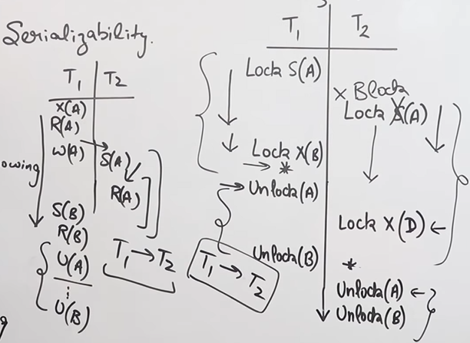
  + **Multiple transactions can get locks based on the compatibility table**
  + **On lock happens growing phase starts**
  + When **unlock happens shrinking phase starts**
* Advantage:
  + **Always ensures serializability**
* Disadvatage:
  + Same as sharing/exclusion lock
  + **May not be free from cascading rollbacks**

**Other Lockings**

* Strict 2PL
  + **Should satisfy basic 2PL**
  + **All exclusive locks should hold until commit/abort**
  + Advantage:
    - **Cascade rollback is no more**
    - Strict recoverable
* Rigorous 2PL
  + Should satisfy basic 2PL
  + **All shared/exclusive locks are hold until commit/abort**
  + Advantage:
    - Same as strict 2PL
* Conservative 2PL
  + **T1 should get all the locks so that there is no deadlocks**
  + T2,T…will not get any lock

**Timestamp Ordering Protocol**

* 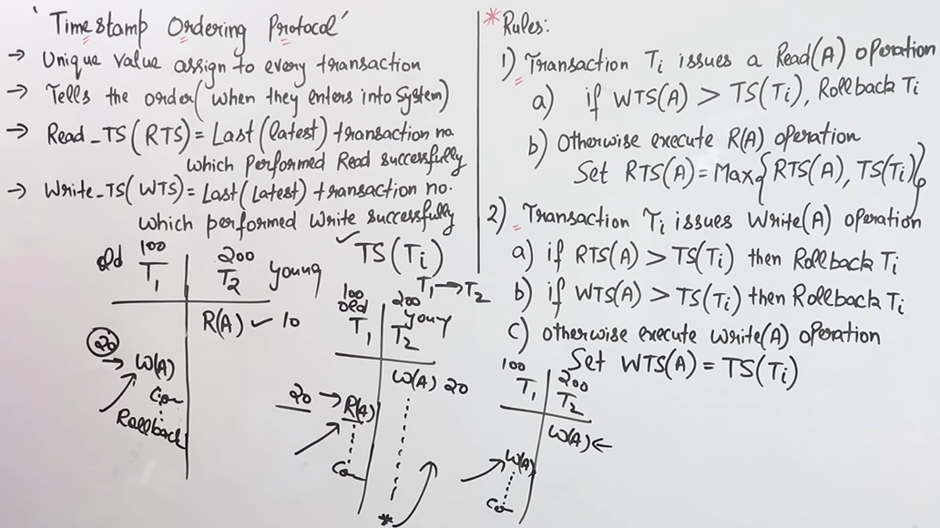
  + **Assignes unique value to every transaction**
  + **Gives us the order of executions**
  + **Read_TS(RTS)**
    - Last transaction which performed read successfully
  + **Write_TS(WTS)**
    - Last transaction which performed write successfully
  + Rules:
    - Transactions issues a Read operation
      * If w(a) in T1 comes after r(a) T2
        + Rollback to Ti
        + Because, what if w(a) fails then r(a) is a dirty read
    - Transaction issues a write operation
      * If r(a) in T1 comes after w(a) T2
        + Rollback to Ti
        + Because, what if w(a) fails then r(a) is a dirty read
      * If w(a) in T1 comes after r(a) T2
        + Rollback to Ti
        + Because, what if w(a) fails then r(a) is a dirty read

**Indexing**

* 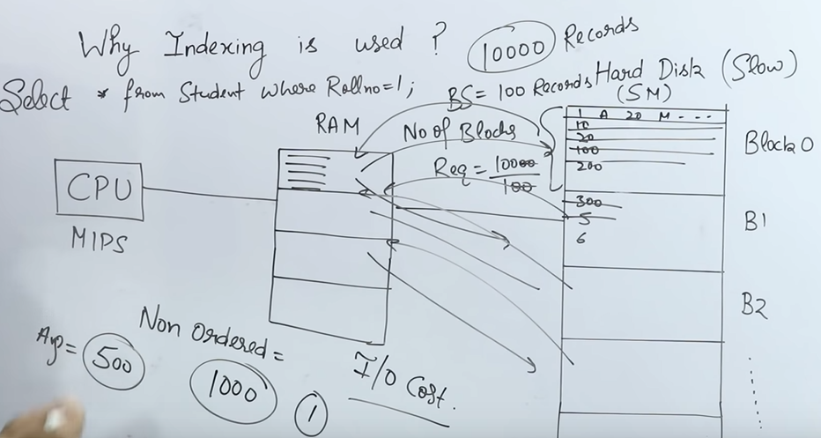
* **Introduction:**
  + **CPU does MIPS(million instruction per sec) through RAM but hard disk is slow**
  + **Hard disk is divided into continuous blocks/pages**
  + **No. of blocks required = total records/100**
* **Suppose we’ve to do a query:** Select * from Student where Roll_no = 1
  + **RAM will retrieve records from hard disk then it’ll do operation and give it back**
  + **It’ll have a I/O Cost, for taking and giving records from hard disk**
  + **To reduce the I/O Cost we use indexing**
* *For example, we’ve to get a page in book so we can get the page by turning 1000 page or 1 page but if see index of the book It’ll be easier to find book.*
* *Indexing is used to optimize the performance of a database by minimizing the number of disk accesses required when a query is processed.*
* *The index is a type of data structure. It is used to locate and access the data in a database table quickly.*
* **Numerical to understand it properly (Without using Indexes):**
  + 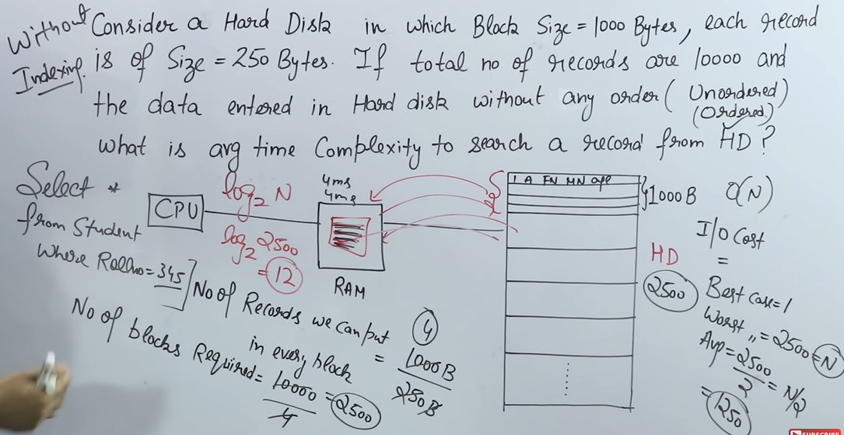
    - Given a ques.lets divide hard disk into 1000 bytes in each block
    - Then no. of records = 1000/250 = 4
    - Each operation will cost 4ms in retriving and returning data
    - We’can do the query in O(1) best time and O(N) in worst time
    - No. of blocks = 10000/4 =2500, Avg = 2500/2 = 1250
    - Even if we do binary search if data is ordered we’ll have Log2N
    - Still, Indexing is faster.
* **Using Indexes**
  + 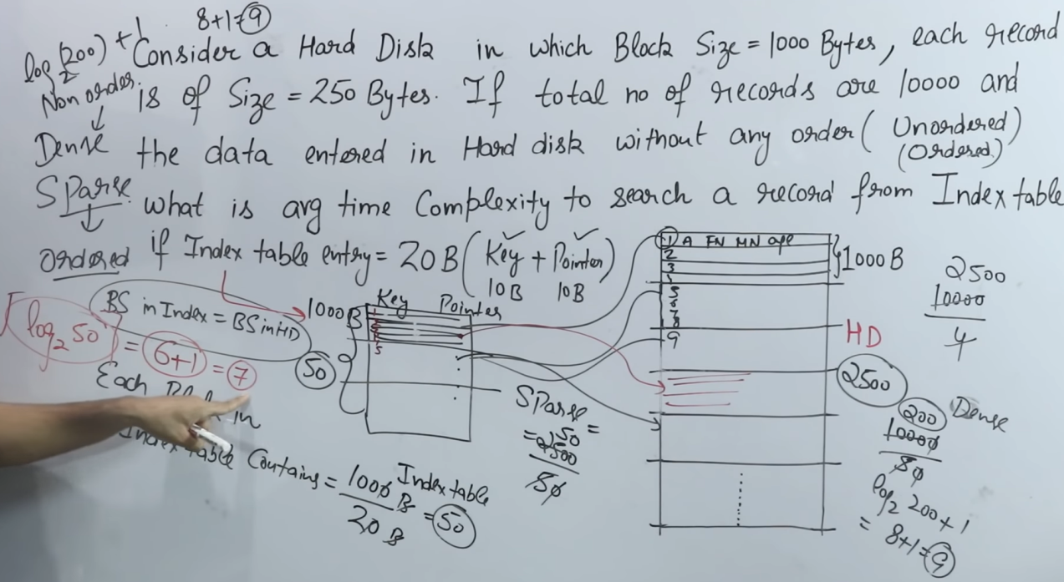
    - For indexes we’ve to give **a key and a pointer**
    - Key will store all the keys and pointer will be used for pointing
    - So data in Block structure(BS) of indexes can be stored in two types:
      * **Dense**
        + Keeping 1 key and 1 pointer in BS structure
        + Used in unordered structure
        + No. of blocks = 10000/50 = 200
        + Log2(200) + 1 = 8+1 = 9

8 for finding in BS in indexes then 1 for pointing to BS of HD

* + - * **Sparse**
        + Keeps 1 BS of HD as a key
        + No. of blocks = 2500/50 = 50
        + Log2(50) = 6 + 1 = 7

6 for finding in BS of indexes and 1 for BS of HD

**Types of Indexes**

* Primary Index
  + **Ordered Values + Key**
  + It can be **dense or sparse coz its ordered**
  + For example, we’ll store student’s marks and key will be roll no
    - 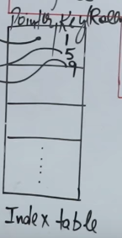
    - BS of index will store blocks of HD
    - If we’ve to find student having roll no 3
      * We’ll find on 1st block coz 2nd block starts with roll no 5 b
    - We’ll have complexity Log2(N) = N + 1 = 7
      * Where N, is no of blocks
      * X, no of times it is searched in BS of index + 1 (searched in HD)
* Secondary Index
  + Non-ordered + key/no key
  + 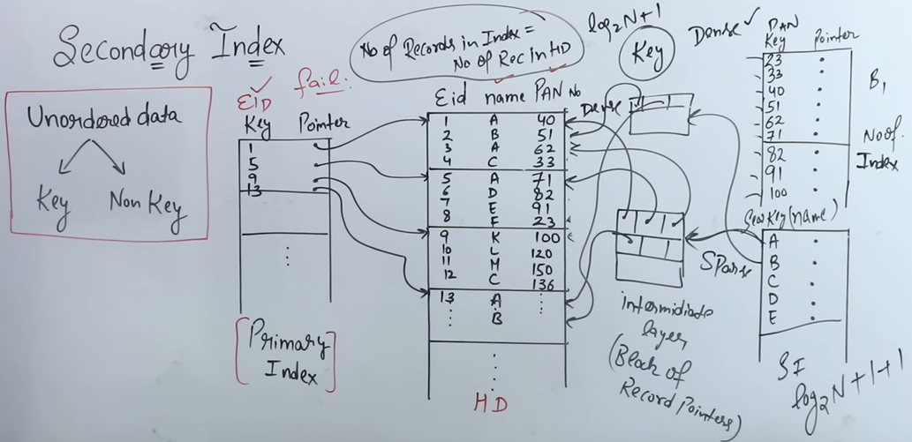
  + Non-ordered + key
    - Same as others process
    - Using **dense process**
    - **No. of records in index = No. of records in HD**
    - Complexity = log2N + 1
  + Non-ordered + no key
    - Let’s take name as key
    - Name has multiple values i.e. we’ll use **intermidiate layer (block of record pointers)**
    - **In intermidate layer, we’ll store all the selected key let’s take it as A, now it will point to all the A’s in the HD.**
    - Complexity: log2N + 1 + 1**(extra for pointing from intermidiate to HD)**
* Clustured Index
  + **Ordered + no key**
  + 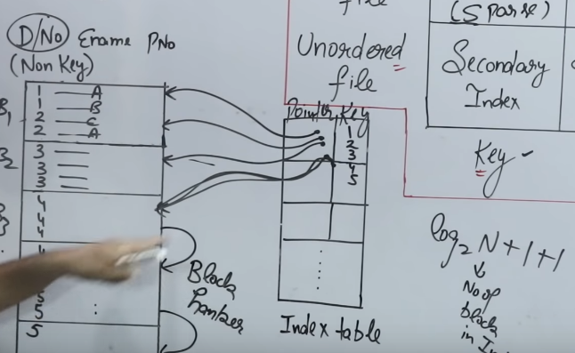
  + It has **no key so there will be repeating values** in the table
  + **Values are repeating in the table but we can have unique values in index table**
  + It is always sparse for easier data usage
  + Sometimes repeated values are in next or previous block so we use ***block hanker*** for that.
  + Complexity: **Log2(N) = N + 1 + 1**
    - Where N is for no. of times it is searched in index + 1 (for searching in table) + 1 (for block hanker)

**B-Tree**

* 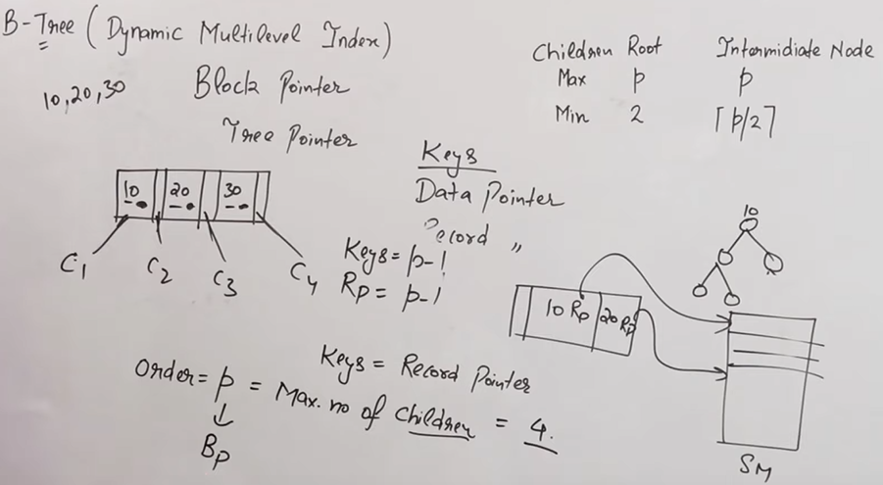
* **B-Tree (Dynamic multilevel index)**
* It is like a binary tree
* It has **block pointer/tree pointer**
* Every block has **key(data pointer) that points to records**
* **Order of P(Tree) = Max. no. of children**
  + **Max children of root = P**
  + **Min children of root = 2**
  + **Max children of intermidiate node = P**
  + **Min children of intermidiate node = P/2**
  + **No. of block pointer = P**
  + **Max. Keys = P-1**
  + **Min. keys = [P/2] – 1**
* Insert
  + 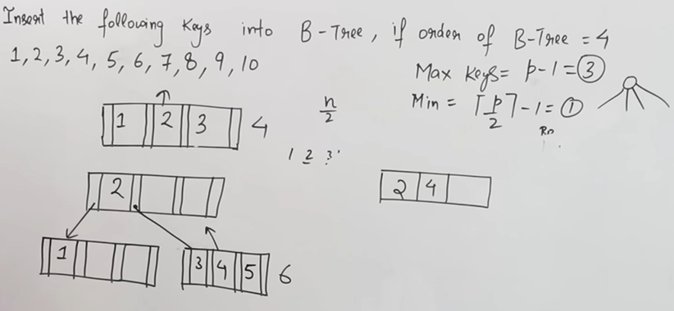
  + This tree will contain max keys of 3 because order is 4
  + We’ll push lower value to left and higher value to right.
  + So, when 4th key comes we take the left median and push the selected median up and adjust the tree.
  + 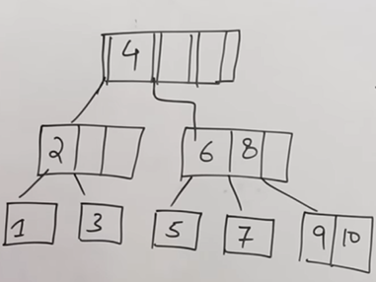
  + This is how fully adjusted tree will look like.

**Difference b/w B tree and B+ tree**

* 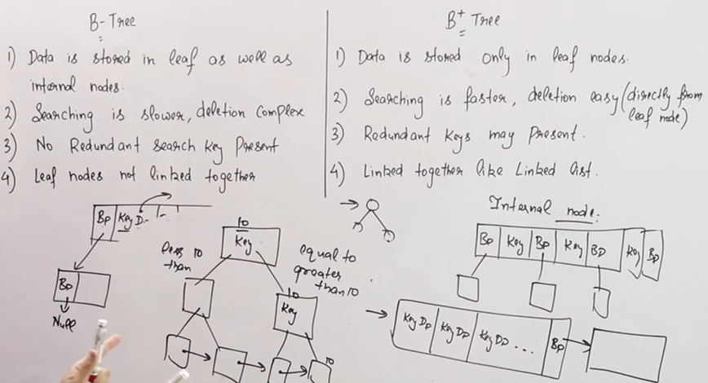
* In B+ tree, data is stored on leaf nodes only
  + In internal nodes, value at root node is present
* In B+ tree, values are stored like linked list
  + That’s why searching and other operations are easy
* In B+ tree, redundant keys may be present

**Immediate Database Modification (Log based recovery)**

* 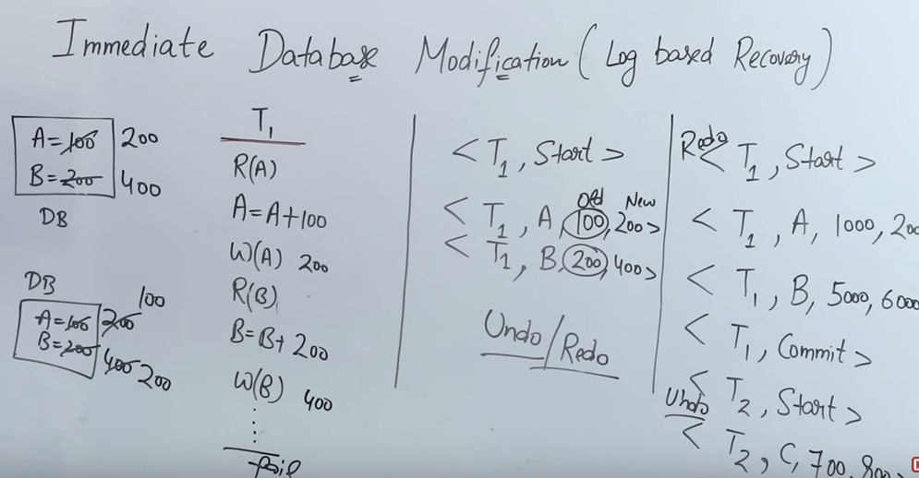
* It means immediate modification in database as a log having old and new logs.
* After commit we do redo and if transaction fails we do undo
  + That’s why we call it undo/redo strategy
* But in deferred database modification we can only do redo.

**Deferred Database modification**

* Deferred means we can say late
* In this database only updates after commit i.e redo
* In this only redo is possible not undo
* It rollsback at starting position after transaction is failed.

**Like Commands**

* 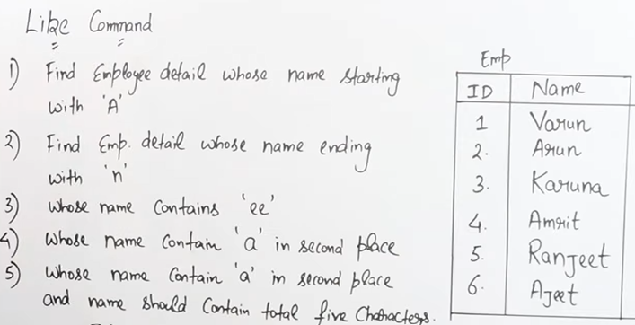
  1. Select * from emp where name Like ‘A%’
  2. Select * from emp where name Like ‘%n’
  3. Select * from emp where name Like ‘%ee%’
  4. Select * from emp where name Like ‘_a%’
  5. Select * from emp where name Like ‘_a___%’

**Pl-SQL Questions for beginners**

* 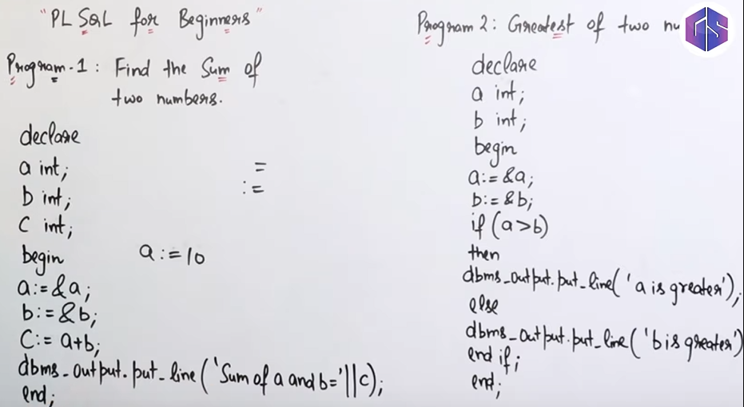
* 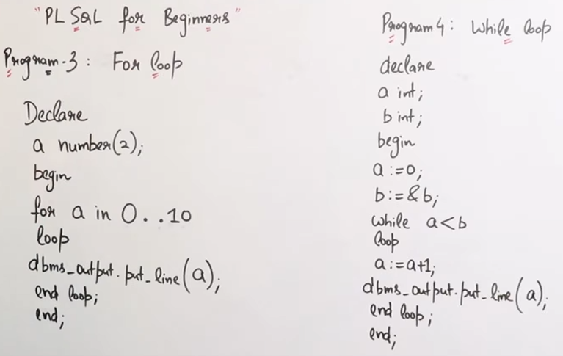

**SQL Functions**

* 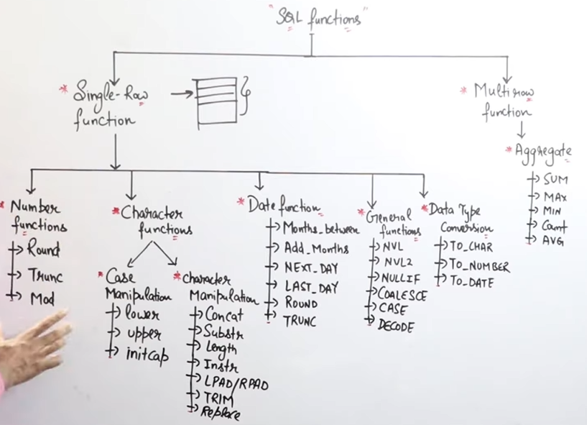
* Single-row function (function applied on only single row)
  + General functions
    - Used for handling null values
* Multi-row function (function applied on multiple rows)
* **Character Functions**
  + 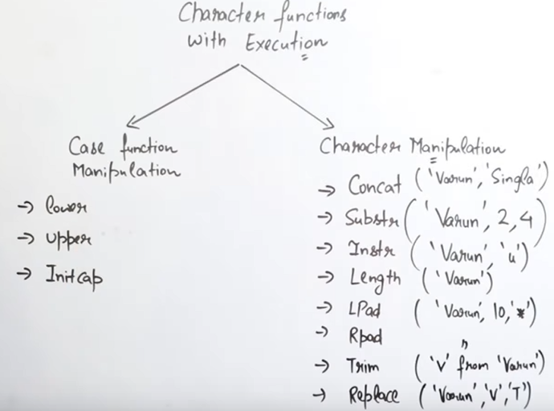
  + **Character functions is divided into two types of execution:**
    - **Case function manipulation**
      * Select lower(name) from emp; //string to lower cap string
      * Select upper(name) from emp; //string to upper cap string
      * Select initcap(name) from emp; //first character will be capital
    - **Character function manipulation**
      * Select concat(id, name) from emp; //will add id and name
      * Select substr(‘Varun’, 2, 4) from emp; //aru
      * Select instr(‘varun’, 4) from emp; //u
      * Select length(name) from emp; //returns length
      * Select lpad(‘varun’, 10, ‘*’) from emp; // *****varun
      * Select rpad(‘varun’, 10, ‘*’) from emp; // varun*****
      * Select trim(‘v’ from ‘varun’) from emp; // arun
      * Select replace(‘varun’, ‘v’, ‘t’) from emp; //tarun

**View**

* **Virtual table**
* **Stores query only**
* **View is the result of stores query**
* **It can be read-only or updatable view**
  + In updatable view, we **can’t do DDL but we can do DML**
* **Materialized View**
  + Storing snapshot or some cache of database from server in our storage
* 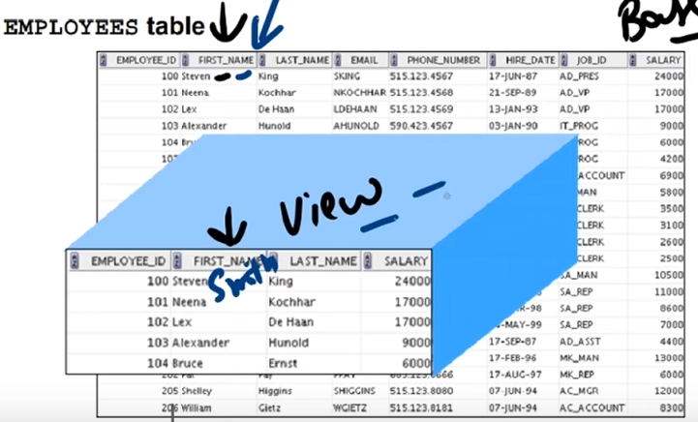
  + If we **change in base table, data in view also changes and vice-versa**
    - But we can make view read-only to prevent that
* **Advantages**:
  + **To restrict data access**
    - Using read-only
  + **To make complex query easy**
    - We can setup differect column of different tables in one view easily with queries
  + **To provide data independence**
    - We can setup different view for same table or same column in table
  + **Provide different view of same data**
    - Maybe student and teacher in a column have different functionality so we can use different view for same data to do operations

**Question: How aggregate functions work on null value?**

* 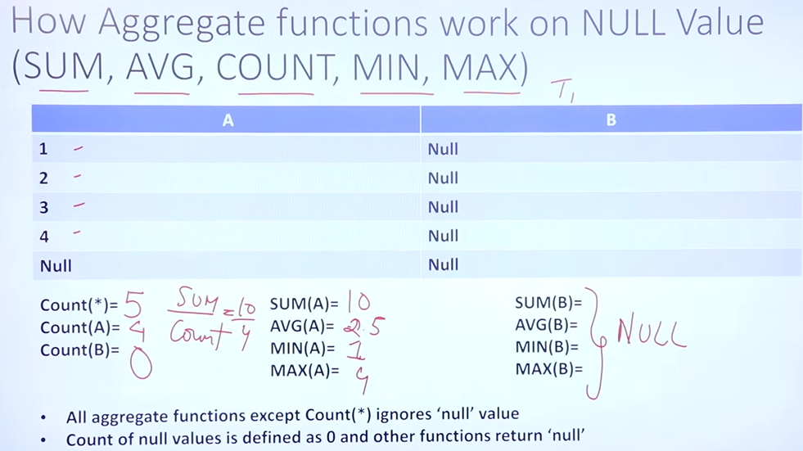

RAID

* Redundant array of independent disks
* Redundant array of inexpensive disks
* Technology used to connect mulitiple secondary memory
  + Increased performance and data redundancy
  + Gives us ability to survive one or more disks failure
* RAID – 0 (Data stripping)
  + 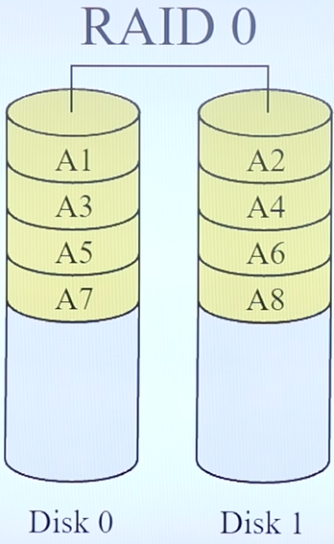
  + Data is divided into multiple parts which gives us high speed access of data i.e. throughput
* RAID – 1 (Mirroring)
  + 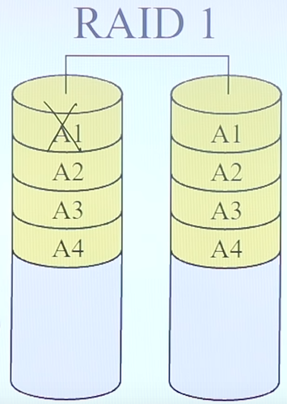
  + Here, same data is stored i.e. mirrorred
  + Incase of failure other data can be used
* RAID 0 + 1
  + 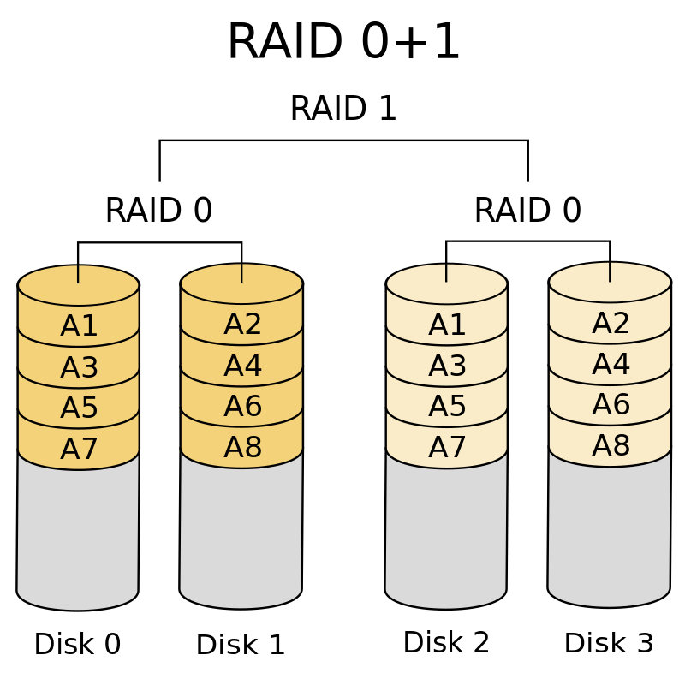
* RAID 3
  + 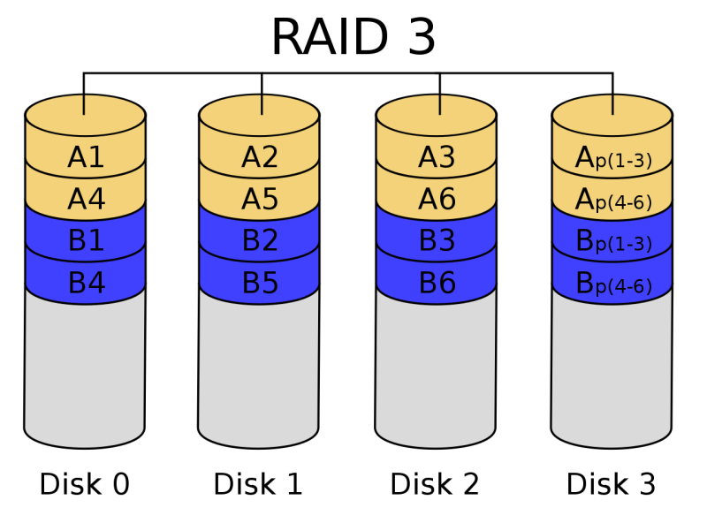
  + Here, data is stored in blocks (A1,2,3) then in parity in last one.
  + If any block is failed we can use parity block.
  + But we can’t access data if more than one block is failed.
  + If we write any of the block, we have to calculate parity
    - Parity will be used many times and it’ll become bottleneck
* RAID 5
  + 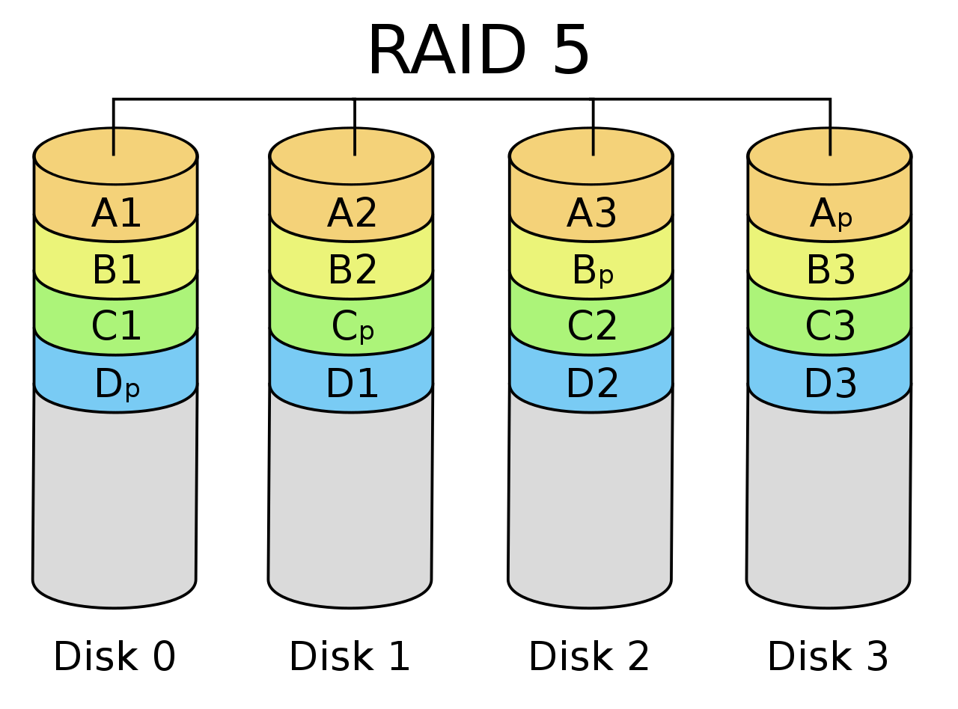
  + Parity in all disks
  + So use of parity is balanced and no parity is overused
* RAID 6
  + 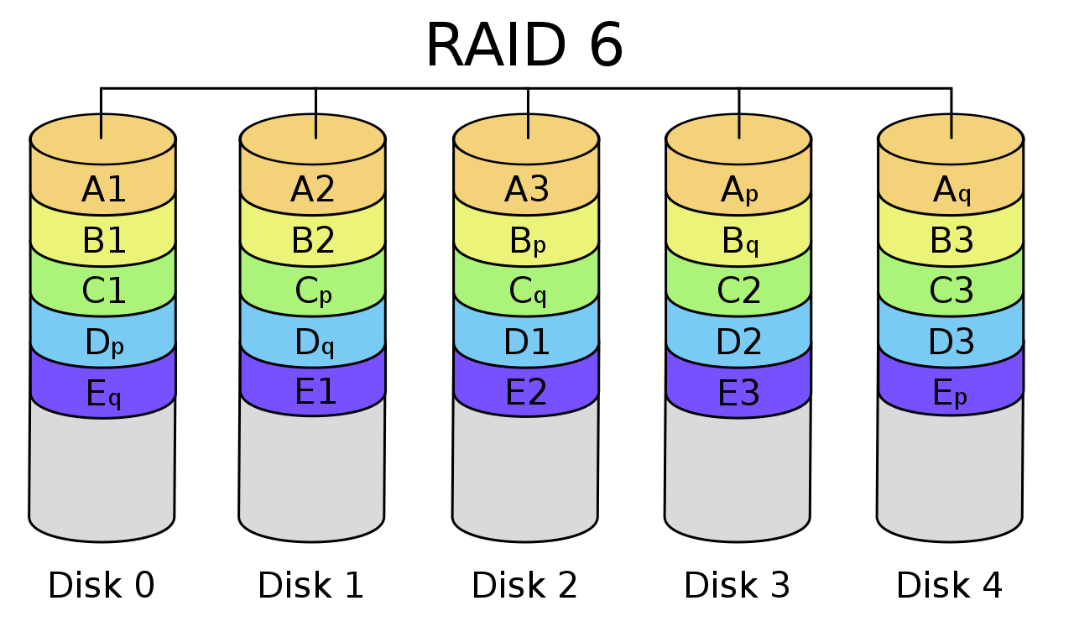
  + We’ve 2 parity
  + If 2 disks fail we can make use of 2 parity two recover them.

**Various Objects in DB**

* 